
BATTISFORD PARISH COUNCIL
Clerk: Teresa Davis 07719208444
clerk@battisfordpc.org.uk
http://www.battisfordpc.org.uk

The PRESS and PUBLIC are invited to attend, the Councillors are SUMMONED TO ATTEND THE BATTISFORD PARISH COUNCIL MEETING to be held at Battisford Village Hall on 23rdNovember 2021 commencing at 7.00pm
Signed: 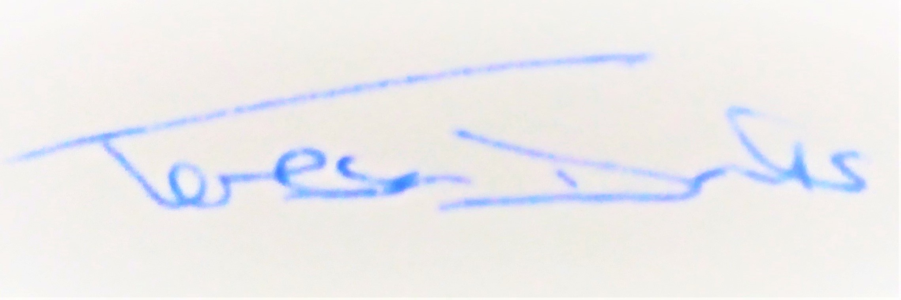
AGENDA
2021/110 | MEETING ADMINISTRATION
a.  b.  c. | Chairman’s welcome & establish any intentions of record the meeting.  Apologies for Absence received – Apologies received by Cllr C Nicholas  Declarations of Interest on agenda items
2021/111  a. | To Approve the Draft Minutes of the Parish Council Meeting of 19th October 2021 and for the Chair to sign as a true record  Matters arising from the minutes of 19th Oct 2021
2021/112 | Co-Option of Parish Councillor
2021/113  a.  b.  c. | PUBLIC PARTICIPATION - For members of the public, County Councillors & District Councillors to speak  Public invited to speak  To receive Suffolk County Council report from Cty Cllr K Oakes  To receive District Council report from Dst Cllr D Pratt
2021/114  a.  b.  c. | Chair and Councillor Reports / Updates (on the night)  Chairman report  Councillor Report(s) eg: Quiet Lanes & Pond, Noticeboards  Clerk report
2021/115 | To Discuss Battisford Boundaries as set out by the Boundary Commission
2021/116 | To Discuss Finborough Post Office
2021/117  a.  b.  c. | Planning Consultation Requests Received for Battisford  DC/21/05833  DC/21/05948  BMSDC HLS (Housing Land Supply) Consultation
2021/118  a.  b. | SID Report & ANPR Initiative update (Cllr Cook)  SID report & update  ANPR update
2021/119  a.  b.  c.  d.  e.  f. | ENVIRONMENTAL/ FACILITY / ASSET MATTERS  To discuss Resident email regarding environmental concern near Mill Rd  BMSDC report No.BMCU373500855  To discuss The Green Play Area ROSPA report  To discuss monthly health and safety checks in the park (Cllr J Cook report)  To discuss a Winter Tree Check  Update on the Bowl Meadow Development  To discuss information given by Dst Cllr D Pratt on Decarbonisation
2021/120 | MATTERS RELATING TO THE CEMETERY
a.  b. | To confirm site of future plot number for member of the public  To receive up-date on Cemetery maintenance
2021/121 | PLATINUM CELEBRATIONS 2022
a.  b.  c. | Village Fete 5th July 2022  Beacon Lighting 2nd June 2022  The Queens Canopy
2021/122  a.  b. | GOVERNANCE and PROTOCOLS  BPC Emergency Plan review (Cllr Wicking)- deferred from last meeting  To discuss moving forward with the Neighbourhood Plan
2021/123  a.  b.  c.  d.  e.  f.  g. | FINANCIAL MATTERS  To Advise of urgent Cheque Payments Made after the 19th October 2021  - SALC Internal Audit – £238.80 (Due August)  - Top Garden Services - £432.00 (cutting in Aug & Sept)  - Final Wages N Cladding - £330.98  - BVHMC (Village Hall Hire) - £100.00  To Advise of Income received up to 31st October 2021  - BMSDC CIL payment relating to DC/21/00499 - £349.85  To discuss and authorise payments of invoices payable in November 2021  - Viking Stationary - £83.49  - Clerk wages for payment on 30th November - £299.78  - Clerk Office Allowance & Mileage - £89.55  - SALC Cemetery Training - £48.00  - Top Garden Services cutting in October - £216.00  - ROSPA Play Safety Report - £111.60  To review and approve Asset Register subject to Bin amendment  To review and approve VAT reclaim for £309.99 for financial year 2020-2021  To discuss and approve PRECEPT & Budget for financial year 2022-2023  To discuss and approve Internal Auditor for financial year 2022-2023
2021/124 | EXCLUDED ITEM – Employment Matters (Holiday & Leaving Dates)
 | To resolve that under the Public Bodies (Admission to meetings) Act 1950 the public be excluded from the meeting due to the confidential nature of the business to be discussed at this item
2021/125 | To Discuss and Set Dates for Parish Council meetings in 2022  Proposed Dates:-  Tues 18th January 2022  Tues 15th March 2022  Tues 17th May 2022 Proposed AVM same day after the Annual PC meeting  Tues 19th Jul 2022  Tues 20th Sept 2022  Tues 15th Nov 2022
2021/126 | Items for the next agenda

