
BATTISFORD PARISH COUNCIL
Clerk: Teresa Davis 07719208444
clerk@battisfordpc.org.uk
http://www.battisfordpc.org.uk

The PRESS and PUBLIC are invited to attend, the Councillors are SUMMONED TO ATTEND THE BATTISFORD PARISH COUNCIL MEETING to be held at Battisford Village Hall on 15th November 2022 commencing at 7.00pm
Signed: 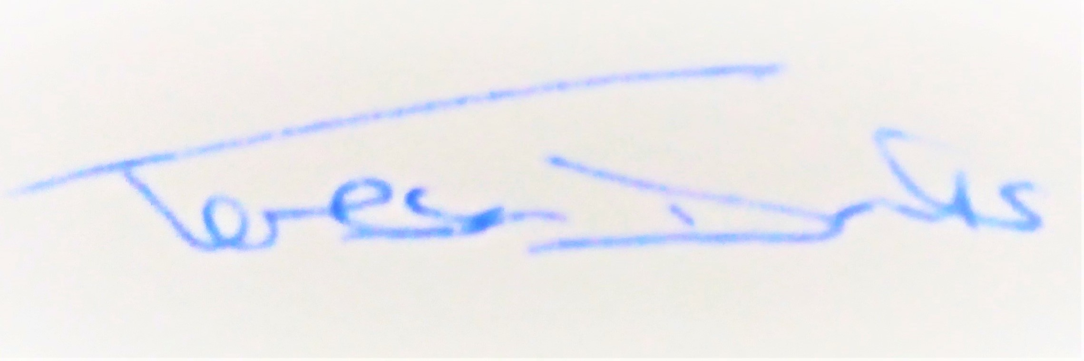
AGENDA
2022/90 | MEETING ADMINISTRATION
a.  b.  c. | Chairman’s welcome & establish any intentions of record the meeting  Apologies for Absence  Declarations of Interest on agenda items
2022/91  a. | To Approve the Draft Minutes of the Parish Council Meeting of 27th September 2022 and for the Chair to sign as a true record  Matters arising from the minutes of 27th Sept 2022
2022/92  a.  b.  c. | PUBLIC PARTICIPATION - For members of the public, County Councillors & District Councillors to speak  Public invited to speak  To receive Suffolk County Council report from Cty Cllr K Oakes  To receive District Council report from Dst Cllr D Pratt
2022/93  a.  b.  c. | Chair and Councillor Reports / Updates (on the night)  Chairman report  Councillor report(s) not requiring a decision  Clerk report
2022/94  a.  b. | SID Report & ANPR Initiative update (Cllr Cook)  SID report & update  ANPR update
2022/95  a.  b.  c.  d. | BMSDC PLANNING CONSULTATION REQUESTS & PLANNING INSPECTORATE CONSULTATION REQUEST RECEIVED  DC/22/ 04758 – Full Planning Application for Open Air Riding Arena, Haven Barns, Straight Rd  DC/22/05074 – Full Planning Application for 2 dwellings and demolition of existing buildings, revised DC/22/03189, David Upson Produce, Stoke Farm Drive  DC/22/05456 – Planning Permission without compliance of condition 2, construction of storage outbuilding with solar panels & modify eastern boundary treatment, Tye Farm, Straight Rd  EN020027 – Planning Inspectorate Scoping Report, East Anglia Green Energy Enablement, National Grid Electricity Transmission
2022/96  a.  b.  c.  d.  e. | GOVERNANCE & PROTOCOLS  To discuss, finalise & approve draft Playground Policy  To approve draft routine playground check  To discuss moving to a gov.uk website domain and email  To sign documents allowing Cllr E Kerry to view bank account online  To Create an employee panel/sub committee for Clerk’s annual appraisal
2022/97  a. | CEMETERY MATTERS  To discuss the Churchyard Wall following Clerk consultation with SALC
2022/98  a.  b.  c.  d.  e.  f.  g.  h.  i. | FINANCIAL MATTERS  To Advise Previous Payments Made after meeting of 27th September 2022  - Top Garden Services for July (late invoice) - £216.00  - Top Garden Services for August (late invoice) - £216.00  - Top Garden Services for Sept (late invoice) - £324.00  - Clerk Wages October - £304.98  - Bank service Charge - £18.00  - Internal Transfer to savings account - £10,000  To Advise of Income received up to 30th September 2022  - Precept - £6,525.00  - Bank Interest - £1.70  To formally note & approve NALC new pay scale pay rise from April 2022  To discuss and authorise payments of invoices payable in November 2022  - Clerk Office Allowance, Expenses & Mileage - £65.00  - Clerk Wages November - £304.98 + NALC payscale increase  - Viking (Ink, Paper & magnets) - £123.63  Balance of Accounts as of 30th September 2022:-  Current Account - £23,321.02  Savings Account - £ _1,246.35  Savings Account - £ _2370.81  To consider and approve 2nd Quarter Accounts  To discuss annual Asset Check  To discuss quotes received for Playground Maintenance  To confirm Quiet Lane voluntary contribution will be £50
2022/99  a.  b.  c.  d.  e. | Ongoing Parish Projects and Resident Communications  To discuss Digital Mapping and PROW (Public Rights of Way)  To discuss the resident communication regarding a Traffic Survey on the now Quiet Lane, Church Rd  To discuss Councillors findings on the Skatepark  To discuss the Thermal Imaging Project  To discuss the Mobile Library stops in Battisford
2022/100 | Items for the next agenda, next meeting on 17th January 2023 at 7pm

Link for Planning https://planning.baberghmidsuffolk.gov.uk/online-applications/

