
BATTISFORD PARISH COUNCIL
Clerk: Teresa Davis 07719208444
clerk@battisfordpc.org.uk
http://www.battisfordpc.org.uk

The PRESS and PUBLIC are invited to attend, the Councillors are SUMMONED TO ATTEND THE BATTISFORD PARISH COUNCIL MEETING to be held at Battisford Village Hall on 18thJanuary 2022 commencing at 7.00pm
Current Covid Guidance will be followed, currently: Keep to social distancing, wearing a mask and please take a Lateral Flow Test before attending if available
Signed: 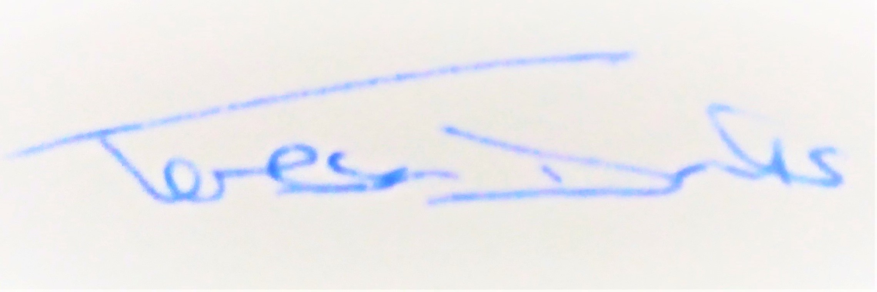
AGENDA
2022/1 | MEETING ADMINISTRATION
a.  b.  c. | Chairman’s welcome & establish any intentions of record the meeting.  Apologies for Absence  Declarations of Interest on agenda items
2022/2  a. | To Approve the Draft Minutes of the Parish Council Meeting of 23rd November 2021 and for the Chair to sign as a true record  Matters arising from the minutes of 23rd Nov 2021
2022/3 | Co-Option of Parish Councillor
2022/4  a.  b.  c. | PUBLIC PARTICIPATION - For members of the public, County Councillors & District Councillors to speak  Public invited to speak  To receive Suffolk County Council report from Cty Cllr K Oakes  To receive District Council report from Dst Cllr D Pratt
2022/5  a.  b.  c. | Chair and Councillor Reports / Updates (on the night)  Chairman report  Councillor Report(s) eg: Quiet Lanes, Noticeboards, Cemetery, The Green  Clerk report
2022/6  a.  b. | SID Report & ANPR Initiative update (Cllr Cook)  SID report & update  ANPR update
2022/7  a.  b.  c.  d. | ENVIRONMENTAL/ FACILITY / ASSET MATTERS  To discuss School Bus – Raised by Resident  To discuss information given by Dst Cllr D Pratt on Decarbonisation  To discuss a Parish Council Collaboration on the Environment as emailed by Dst Cllr D Pratt  To discuss the option of playground safety training offered by Playsafety Ltd for £329 in Feb & Sept at either Brentwood or Huntingdon
2022/8 | PLATINUM CELEBRATIONS 2022
a. | The Queens Canopy
2022/9  a.  b. | GOVERNANCE and PROTOCOLS  To Discuss moving forward with the Neighbourhood Plan  To Review and Approve proposed Playground Risk Policy
2022/10  a.  b.  c.  d.  e.  f. | FINANCIAL MATTERS  To Advise of urgent Cheque Payments Made after the 30th November 2021  - Mr D Windle – £175.00  - Mr Q J Andrade - £100.00  - 31st Dec Clerk Wages - £299.78  To Advise of Income received up to 31st December 2021  - Burial Rights 106 - £82.50  To discuss and authorise payments of invoices payable in January 2022  - Clerk wages January - £299.78  - Clerk Office Allowance & Mileage - £29.70  Balance of Accounts as of 31st December 2021:-  Current Account - £16526.50  Savings Account - £__643.49  Savings Account - £_2370.51  To review and approve 3rd Quarter Accounts ending 31st December 2021  To discuss & approve PRECEPT (and review Budget) 2022-2023
2022/11 | EXCLUDED ITEM – Employment Matters (Payroll)  To resolve that under the Public Bodies (Admission to meetings) Act 1950 the public should now be excluded from this meeting due to the confidential nature of the business to be discussed at this item
2022/12 | Items for the next agenda

