
BATTISFORD PARISH COUNCIL
Clerk: Teresa Davis 07719208444
clerk@battisfordpc.org.uk
http://www.battisfordpc.org.uk

The PRESS and PUBLIC are invited to attend, the Councillors are SUMMONED TO ATTEND THE BATTISFORD PARISH COUNCIL MEETING to be held at Battisford Village Hall on 19th July 2022 commencing at 7.00pm
Signed: 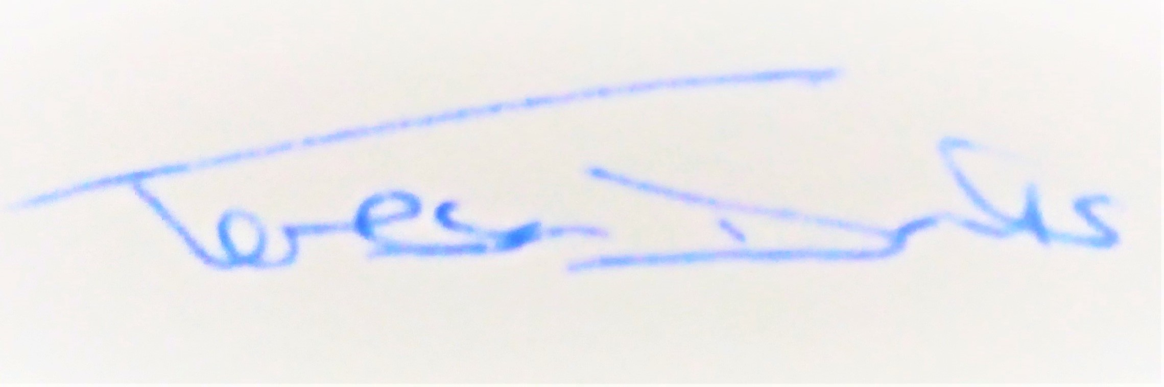
AGENDA
2022/61 | MEETING ADMINISTRATION
a.  b.  c. | Chairman’s welcome & establish any intentions of record the meeting  Apologies for Absence  Declarations of Interest on agenda items
2022/62  a. | To Approve the Draft Minutes of the Extraordinary Parish Council Meeting of 7th June 2022 and for the Chair to sign as a true record  Matters arising from the minutes of 7th June 2022
2022/63  a.  b.  c. | PUBLIC PARTICIPATION - For members of the public, County Councillors & District Councillors to speak  Public invited to speak  To receive Suffolk County Council report from Cty Cllr K Oakes  To receive District Council report from Dst Cllr D Pratt
2022/64  a.  b.  c. | Chair and Councillor Reports / Updates (on the night)  Chairman report  Councillor report(s) not requiring a decision  Clerk report
2022/65  a.  b. | SID Report & ANPR Initiative update (Cllr Cook)  SID report & update  ANPR update
2022/66  a.  b.  c.  d.  e. | BMSDC PLANNING CONSULTATIONS REQUESTS RECEIVED  DC/22/02859 – Householder Application – Single Storey Extension, Ronfield, Battisford  DC/22/03096 – Householder Application – Extensions, The Bellows, Battisford  DC/22/03379 – Determination of Prior Approval – Pumping Station – Manor Farm, Battisford  DC/22/03406 – Determination of Prior Approval – Farm Office/Machinary Store - Manor Farm, Battisford  DC/22/03405 – Determination of Prior Approval – Crop Store – Manor Farm, Battisford
2022/67  a. | GOVERNANCE and PROTOCOLS  To discuss outcome of public consultation/feedback at the Battisford Fete regarding a Parish or Neighbourhood Plan
2022/68  a.  b.  c.  d.  e.  f. | FINANCIAL MATTERS  To Advise Previously Payments Made after meeting of 7th June 2022  - Top Garden Services for April (late invoice) – £324.00  - Discounted SALC Audit Fees - £182.00  - SALC Budgeted Training - £48.00  - Replacement Defibrillator Pads - £115.20  - BMSDC Budgeted Dog & Litter Bin Waste Collection - £350.05  - Battisford Village Hall Grant Request - £300.00  - Battisford Jubliee Celebration Donation - £300.00  - Clerk Wages February - £304.98  - Bank Charges - £18.00  To Advise of Income received up to 30th June 2022  - BMSDC Precept - £6,525.00  - BMSDC CIL - £349.85  - Bank Interest - £0.99  To discuss and authorise payments of invoices payable in July 2022  - Clerk Office Allowance, Expenses & Mileage – £63.26  - Clerk Wages July - £304.98  Balance of Accounts as of 30th June 2022:-  Current Account - £19.185.45  Savings Account - £__944.65  Savings Account - £_2370.91  To review and approve the First Quarter Accounts  To review donation request received from the Four Parishes News Magazine
2022/69  a. | Resident Communications  To discuss the email received regarding Quiet Lane Signage and speeding, large vehicles on the Quiet Lane (inc photos).
2022/70 | Items for the next agenda, next meeting on 20th Sept 2022

