
BATTISFORD PARISH COUNCIL
Clerk: Teresa Davis 07719208444
clerk@battisfordpc.org.uk
http://www.battisfordpc.org.uk

Due to the sad passing of Her Majesty Queen Elizabeth II our scheduled meeting of 20th September has been postponed.
The PRESS and PUBLIC are invited to attend, the Councillors are SUMMONED TO ATTEND THE BATTISFORD PARISH COUNCIL MEETING to be held at Battisford Village Hall on 27th September 2022 commencing at 7.00pm
Signed: 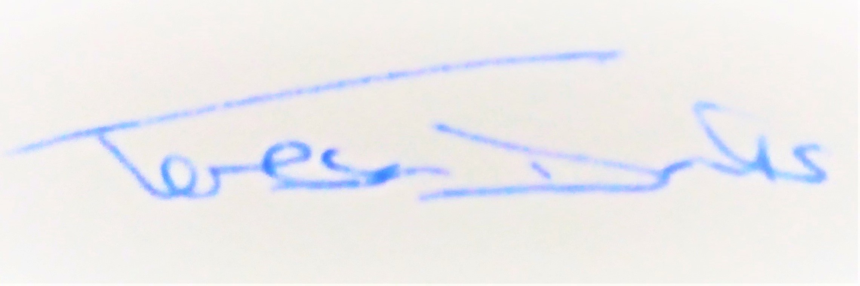
AGENDA
2022/79 | MEETING ADMINISTRATION
a.  b.  c. | Chairman’s welcome & establish any intentions of record the meeting  Apologies for Absence  Declarations of Interest on agenda items
2022/80  a. | To Approve the Draft Minutes of the Extraordinary Parish Council Meeting of 4th August 2022 and for the Chair to sign as a true record  Matters arising from the minutes of 4th August 2022
2022/81  a.  b.  c. | PUBLIC PARTICIPATION - For members of the public, County Councillors & District Councillors to speak  Public invited to speak  To receive Suffolk County Council report from Cty Cllr K Oakes  To receive District Council report from Dst Cllr D Pratt
2022/82  a.  b.  c. | Chair and Councillor Reports / Updates (on the night)  Chairman report  Councillor report(s) not requiring a decision  Clerk report
2022/83  a.  b. | SID Report & ANPR Initiative update (Cllr Cook)  SID report & update  ANPR update
2022/84  a.  b.  c.  d.  e.  f.  g. | BMSDC PLANNING CONSULTATIONS REQUESTS RECEIVED  DC/22/ 03948 – Application: conversion of barn and building to 1 dwelling, Barn at Gibbons Farm, Battisford  DC/22/04108 – Application: single storey side ext, The Maples, Mill Rd, Battisford  DC/22/04159 – Application removal of conditions: change of use and alterations to land and buildings, Moats Tye Livery, Moats Tye, Combs  DC/22/04409 – Application: 2 storey rear ext, Woodlands Farm, Bildeston Rd, Ringshall  DC/22/04410 – Listed building consent as per DC/22/04409  DC/22/04394 – Listed building consent as per DC/22/04394  DC/22/04393 – Application: Solar Panels on Office Roof East & West, Bungeons Farm, Battisford Rd, Barking
2022/85  a.  b.  c.  d. | GOVERNANCE & PROTOCOLS  To discuss draft Financial Risk Assessment  To discuss draft Internal Control  To discuss Cemetery Fees  To discuss Data Protection Review
2022/86  a.  b.  c. | CEMETERY MATTERS  To discuss the Cemetery Fee’s  To discuss the Annual Topple Test  To discuss the Churchyard Wall
2022/87  a.  b.  c.  d.  e.  f. | FINANCIAL MATTERS  To Advise Previous Payments Made after meeting of 4th August 2022  - Top Garden Services for May (late invoice) - £216.00  - Top Garden Services for June (late invoice) - £216.00  - Clerk Wages August - £304.98  - Cancellation Fee Playsafety Ltd (ROSPRA) - £111.00  To Advise of Income received up to 31st August 2022  - Cemetery Burial Fee - £300.00  To discuss and authorise payments of invoices payable in Sept 2022  - Clerk Office Allowance, Expenses & Mileage - £33.05  - Clerk Wages Sept - £304.98  - Cemetery Training SALC - £48.00  - One Day Routine Playground Inspectors Course Training SALC - £252  - Councillor Training (modules 1-3) Cllr Kerry SALC - £93.60  - BHIB Insurance Renewal, 2nd yr of lock in - £373.58  Balance of Accounts as of 31st August 2022:-  Current Account - £18,030.23  Savings Account - £ _1,244.65  Savings Account - £ _2370.91  To discuss and confirm remaining ‘opted In’ with the SAAA for the Appointed External Auditor  To discuss extending the existing Top Garden Services to encompass maintaining the closed Churchyard of St Mary’s, Battisford, following quotes for  - Initial £120 + VAT  - 14 days £36 + VAT  - Monthly £48 + VAT
2022/88  a.  b.  c. | Ongoing Parish Projects and Resident Communications  To discuss the Quiet Lane Signage  To discuss the Pond  To discuss the resident email regarding a Skatepark idea
2022/89 | Items for the next agenda, next meeting on 15th Nov 2022 at 7pm

Link for Planning https://planning.baberghmidsuffolk.gov.uk/online-applications/

