
BATTISFORD PARISH COUNCIL
Clerk: Teresa Davis 07719208444
clerk@battisfordpc.org.uk
http://www.battisfordpc.org.uk

The PRESS and PUBLIC are invited to attend, the Councillors are SUMMONED TO ATTEND THE BATTISFORD PARISH COUNCIL MEETING to be held at Battisford Village Hall on 18th July 2023 commencing at 7.00pm
Signed: 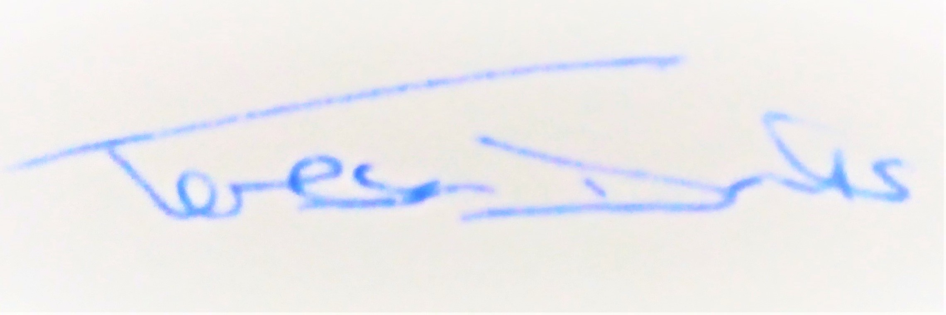
AGENDA
2023/55 | MEETING ADMINISTRATION
a.  b.  c.  d.  e. | Chairman’s welcome & establish any intentions of record the meeting  Apologies for Absence  Notification of Resignation  Co-opting of Councillors  Declarations of Interest on agenda items
2023/56  a. | To Approve the Draft Minutes of the Extraordinary Parish Council Meeting of 20th June 2023 and for the Chair to sign as a true record  Matters arising from the minutes of 20th June 2023
2023/57  a.  b.  c. | PUBLIC PARTICIPATION - For members of the public, County Councillors & District Councillors to speak  Public invited to speak  To receive Suffolk County Council report from Cty Cllr K Oakes  To receive District Council report from Dst Cllr D Pratt
2023/58  a.  b.  c. | Chair and Councillor Reports / Updates (on the night)  Chairman report  Councillor report(s) not requiring a decision  Clerk report
2023/59  a.  b. | SID Report & ANPR Initiative update (Cllr Cook)  SID report & update  ANPR update
2023/60  a. | BMSDC & National PLANNING CONSULTATIONS RECEIVED  National Grid Norwich to Tilbury Consultation
2023/61  a.  b.  c.  d.  e.  f.  g.  f. | GOVERNANCE and PROTOCOLS  To discuss & agree the need for a yearly Action Plan  To discuss & agree the need for a 3yr Budget  To confirm the new Bank signatures & for the RFO to ensure a banking mandate is completed  To discuss carrying out a Tree & Woodland Plan Survey  To discuss forming a Working Party to review the Emergency Plan  To discuss responsibilities of Councillors  To discuss having a mobile phone for Battisford PC  New Standing Item – PPP progress from the working group
2023/62  a.  b.  c.  d.  e.  f. | FINANCIAL MATTERS  Balance of Accounts as of 30th June 2023:-  Current Account - £6,738.13  Savings Account - £12,320.26  Savings Account - £0.00 (old account transferred 26/04/23)  To Advise of Income received up to 30th June 2023  - Bank Interest - £67.53  - Cemetery Fees - £400.00  To Advise of payments made since 20th June 2023 meeting  - Clerk Wages June - £330.98  - Bank Charges - £18.00  To discuss and authorise payments of invoices payable in July 2022  - Clerk Office Allowance, Expenses & Mileage – £43.40  - Clerk Wages July - £330.98  To receive report from Cllr Kerry and to review and approve the First Quarter Accounts  To consider the D-Day 80yr Anniversary arising in 2024 and if a budget should be put in place
2023/63  a.  b. | Resident Communications  To discuss the recent Verge Cutting by Highways and the cut Flowers  To discuss the email received regarding development along the Quiet Lane.
2023/64 | Items for the next agenda, next meeting on 19th Sept 2023

