
BATTISFORD PARISH COUNCIL
Clerk: Teresa Davis 07719208444
clerk@battisfordpc.org.uk
http://www.battisfordpc.org.uk

The PRESS and PUBLIC are invited to attend, the Councillors are SUMMONED TO ATTEND THE BATTISFORD PARISH COUNCIL MEETING to be held at Battisford Village Hall on 19th Sept 2023 commencing at 7.00pm
Signed: 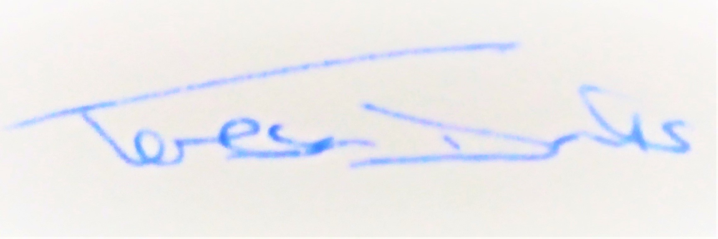
AGENDA
2023/65 | MEETING ADMINISTRATION
a.  b.  c. | Chairman’s welcome & establish any intentions to record the meeting  Apologies for Absence – Cllr A Card  Declarations of Interest on agenda items
2023/66  a. | To Approve the Draft Minutes of the Parish Council Meeting of 18th July 2023 and for the Chair to sign as a true record  Matters arising from the minutes of 18th July 2023  Dst Cllr D Pratt – Traffic and HGV Management Plan update  Cllr Cook to forward ANPR details to Cty Cllr Oakes  Cty Cllr K Oakes – ANPR Camera application update  Cllr Greenwood to forward details of hole in road to Cllr Oakes
2023/67  a.  b.  c. | PUBLIC PARTICIPATION - For members of the public, County Councillors & District Councillors to speak  Public invited to speak  To receive Suffolk County Council report from Cty Cllr K Oakes  To receive District Council report from Dst Cllr D Pratt
2023/68  a.  b.  c. | Chair and Councillor Reports / Updates (on the night)  Chairman report  Councillor report(s) not requiring a decision  Clerk report
2023/69  a.  b.  c.  d. | SID Report, ANPR Initiative update & Speed Safety (Cllr Cook)  SID report & update  ANPR update  Sign Warning of Children Playing to be purchased and reimbursed by Cty Cllr Oakes  To discussing contacting the landowner before putting up the White Fencing
2023/70  a. | BMSDC & National PLANNING CONSULTATIONS RECEIVED  None
2023/71  a.  b.  c.  d.  e.  f. | GOVERNANCE and PROTOCOLS  To discuss & agree the draft Action Plan  PPP progress from the working group  To consider either budgeting for the D-Day 80yr Anniversary arising in 2024 and/or the 80th Anniversary of V E Day in May 2025.  To discuss the new and emerging Taxi-bus service  To consider having a Flower Arrangement in the Church Annual Flower Show  To discuss the current condition of the Cemetery Gates
2023/72  a.  b.  c.  d. | FINANCIAL MATTERS  Balance of Accounts as of 31st August 2023:-  Current Account - £6,032.77  Savings Account - £12,320.26  To Advise of payments made since 18th July 2023 meeting  - Clerk Wages August - £330.98  - Top Garden Payment Apr - £295.20  - Top Garden Payment May - £295.20  - Top garden Payment June - £414.00  - Top Garden Payment July - £295.20  - Top Garden Payment Aug - £295.20  To discuss and authorise payments of invoices payable in Sept 2023  - Clerk Office Allowance, Expenses & Mileage – £43.40  - Clerk Wages Sept - £330.98  - MSDC Non-Contested Election - £137.73  - BHIB Insurance 3rd Yr of Lock In - £398.58  To consider the enquiry made by the Village Hall regarding Insulation Funding
2023/73  a. | Resident Communications  Horse Chestnut Trees
2023/74 | Items for the next agenda, next meeting on 21st Nov 2023

